# CS 255 System Design Document Template

This template lays out all the different sections that you need to complete for Project Two. Each section has guidance to prompt your thinking. You will need to continually reference the interview transcript as you work to make sure that you are addressing your client’s needs. There is no required length for the final document. Instead the goal is to complete each section based on what your client’s needs are. Remove this note when you are finished, and replace all bracketed text with the relevant information.

## UML Diagrams

### UML Use Case Diagram

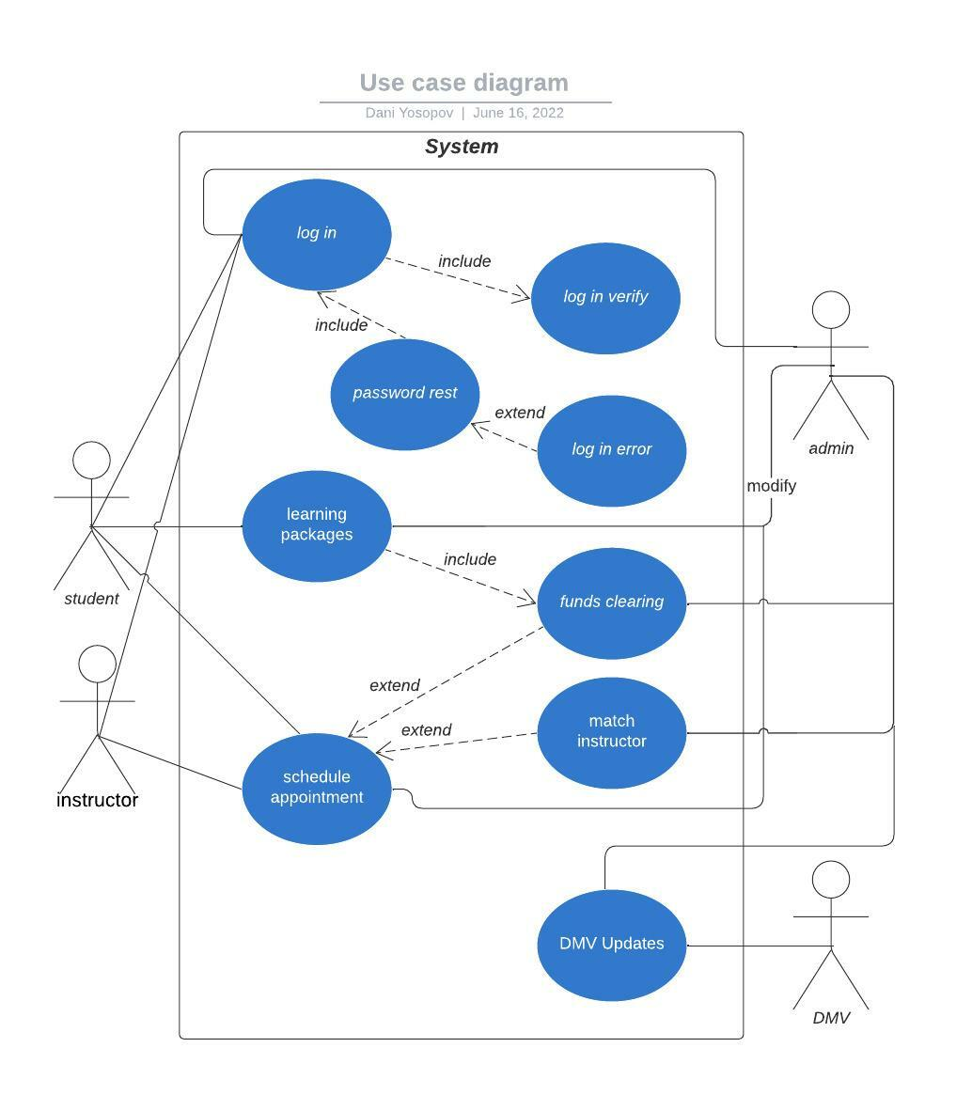

### UML Activity Diagrams

### UML Sequence Diagram

### UML Class Diagram

## Technical Requirements

The system shall validate user credentials when logging in.

The system shall allow the users and admins to schedule and modify training by time and date.

The system shall give detailed information about driving reservations.

The system shall allow the admins the ability to modify the purchase packages.

The system shall allow users to purchase packages.

The system shall allow the admins to match instructors to users.

The system shall be accessible and reliable.

The system shall provide access to content based on user privilege.

The system shall allow access to practice tests and courses.

The system shall track user progress through courses.